**Github :** [**https://github.com/sundershyam04/Phase-4-Jenkins-Practice-Project.git**](https://github.com/sundershyam04/Phase-4-Jenkins-Practice-Project.git)

**Created new project item**

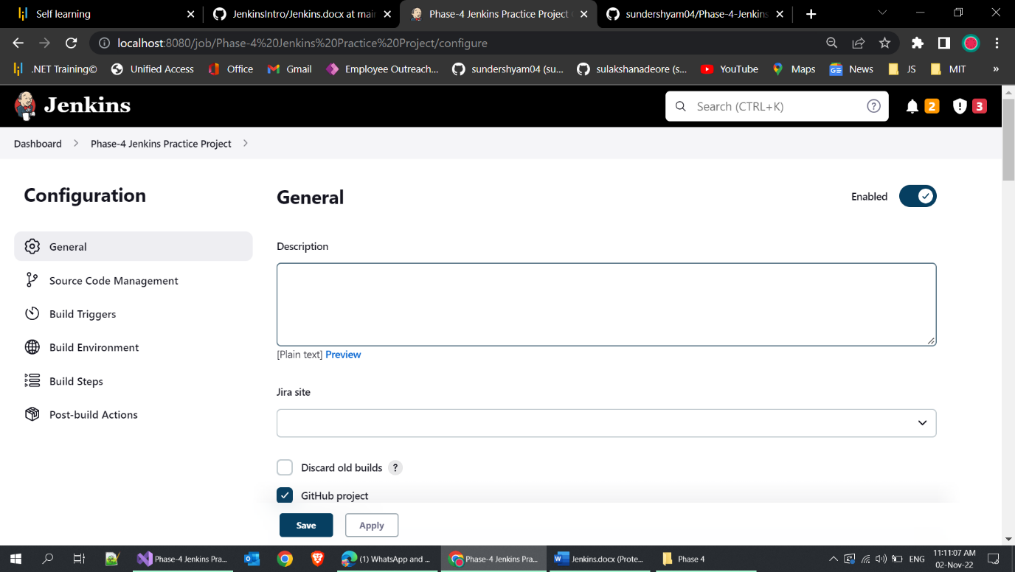

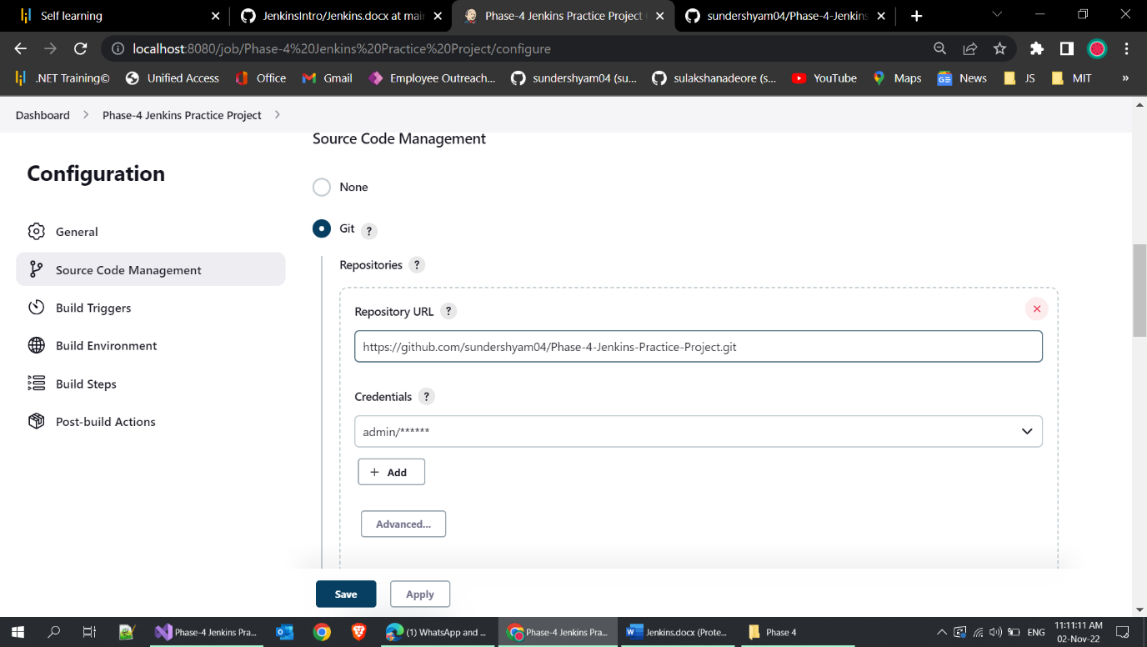

**Set github repo link**

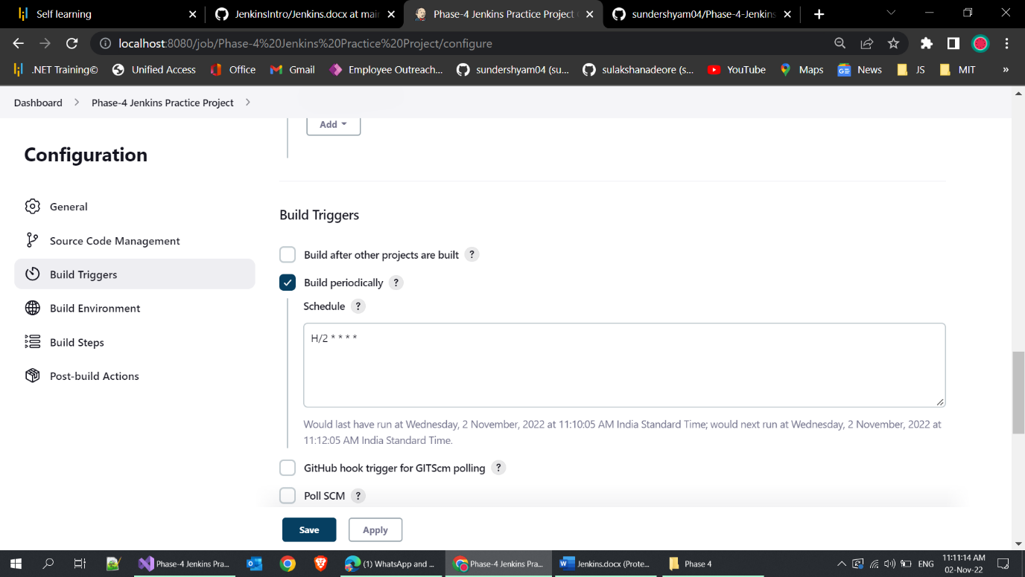

**Build set to 2 minutes once automatically**

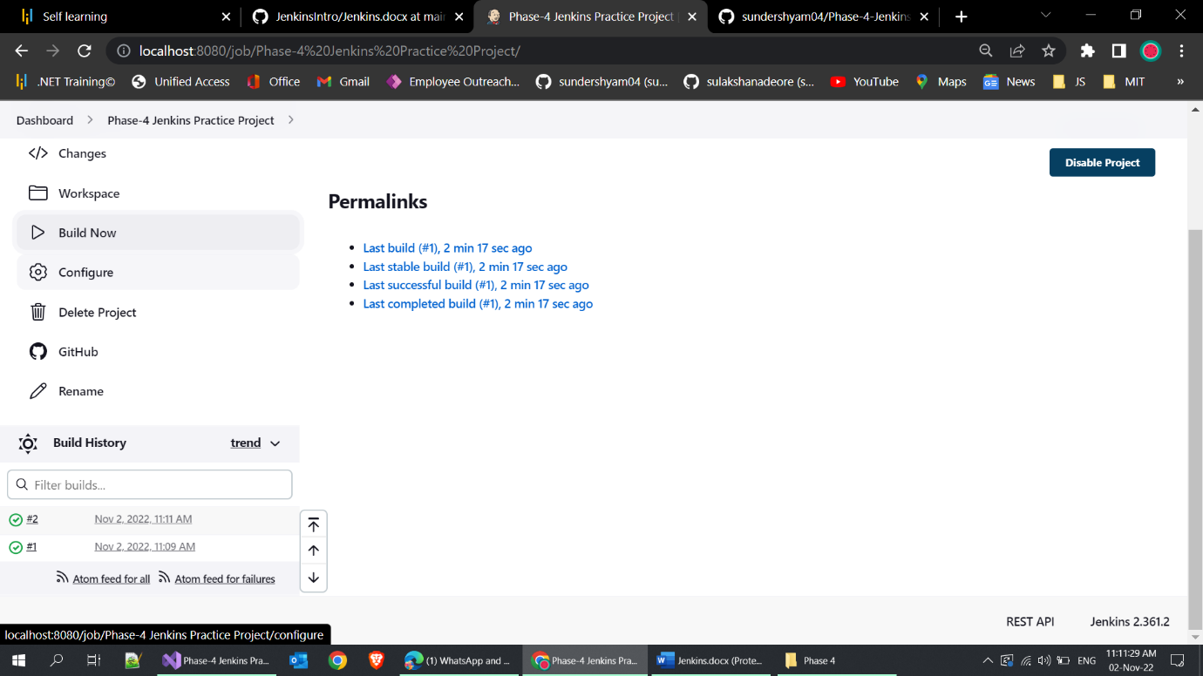

Build succeded

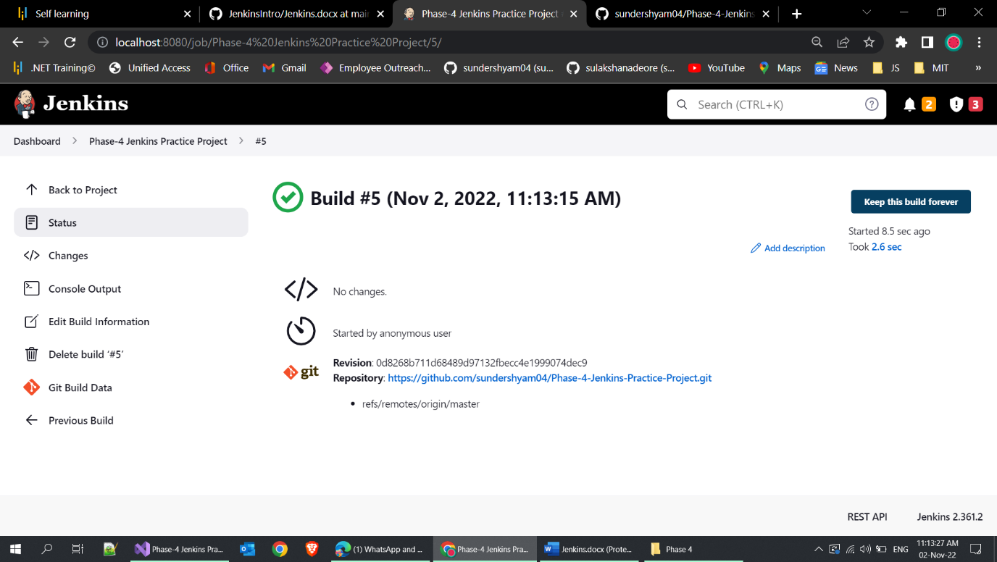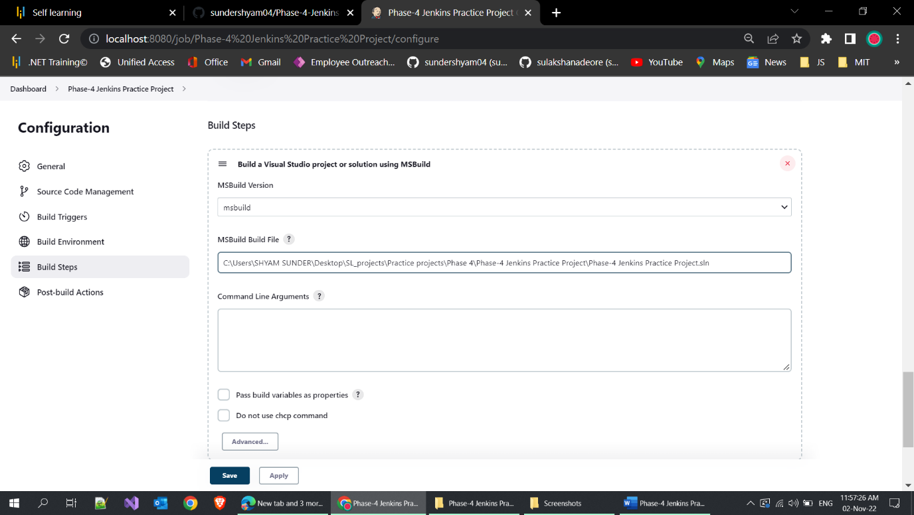

Ms-build setted and builded

